Architecture of environment
23 May 2026 09:48:11

 | Purpose
 | Architecture of environment | 2 | / 13
 | Views
 | Инфраструктурный слой
 | No viewpoint
 | Architecture of environment | 3 | / 13
 | 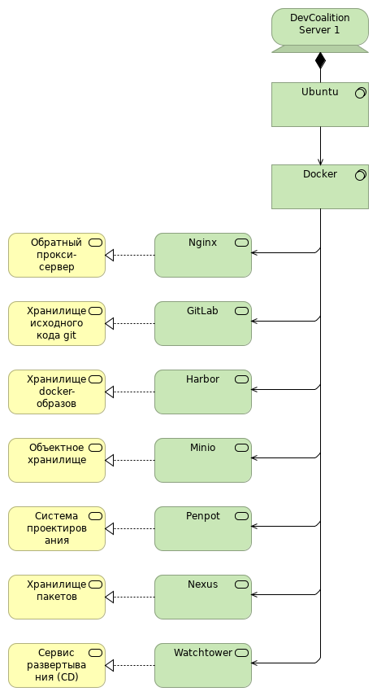
 | Architecture of environment |  | 4 | / 13
 | Elements
 | Element | Type
 | DevCoalition Server 1 | Device (Bare Metal Server)
 | Docker | System Software (Container Management System)
 | GitLab | Technology Service
 | Harbor | Technology Service
 | Minio | Technology Service
 | Nexus | Technology Service
 | Nginx | Technology Service
 | Penpot | Technology Service
 | Ubuntu | System Software (Operation System)
 | Watchtower | Technology Service
 | Обратный прокси-сервер | Business Service
 | Объектное хранилище | Business Service
 | Сервис развертывания (CD) | Business Service
 | Система проектирования дизайна | Business Service
 | Хранилище docker-образов | Business Service
 | Хранилище исходного кода git | Business Service
 | Хранилище пакетов | Business Service
 | Architecture of environment |  | 5 | / 13
 | Сервера
 | No viewpoint
 | 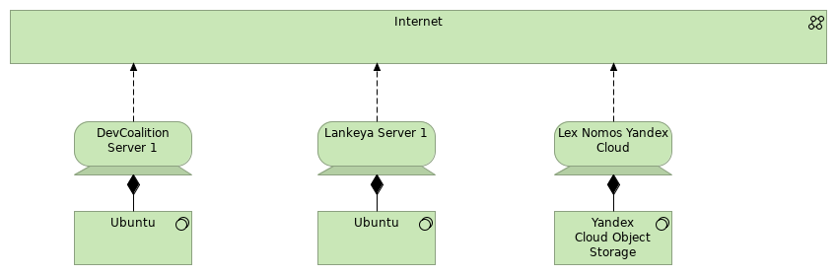
 | Elements
 | Element | Type
 | DevCoalition Server 1 | Device (Bare Metal Server)
 | Internet | Communication Network
 | Lankeya Server 1 | Device (Virtual Private Server)
 | Lex Nomos Yandex Cloud | Device
 | Ubuntu | System Software (Operation System)
 | Ubuntu | System Software (Operation System)
 | Yandex Cloud Object Storage | System Software
 | Architecture of environment |  | 6 | / 13
 | Business Layer
 | Обратный прокси-сервер
 | Type | Business Service
 | Объектное хранилище
 | Type | Business Service
 | Сервис развертывания (CD)
 | Type | Business Service
 | Система проектирования дизайна
 | Type | Business Service
 | Хранилище docker-образов
 | Type | Business Service
 | Хранилище исходного кода git
 | Type | Business Service
 | Хранилище пакетов
 | Type | Business Service
 | Architecture of environment |  | 7 | / 13
 | Application Layer
 | Gitlab docker compose
 | Type | Application Service
 | Architecture of environment |  | 8 | / 13
 | Technology & Physical Layer
 | DevCoalition Server 1
 | Type | Device (Bare Metal Server)
IPv4 | 92.255.207.27
FQDN | devcoalition.tech

 | Docker
 | Type | System Software (Container Management System)
  Version | 24.0.2
 | GitLab
 | Type | Technology Service
 | Harbor
 | Type | Technology Service
 | Internet
 | Type | Communication Network
 | Lankeya Server 1
 | Type | Device (Virtual Private Server)
IPv4 | 89.111.173.244
FQDN | lankeya.com, lankeya.ru, ланкея.рф

 | Lex Nomos Yandex Cloud
 | Type | Device
  FQDN | lex-nomos.ru
 | Minio
 | Type | Technology Service
 | Nexus
 | Type | Technology Service
 | Nginx
 | Type | Technology Service
 | Penpot
 | Type | Technology Service
 | Ubuntu
 | Type | System Software (Operation System)
 | Architecture of environment |  | 9 | / 13
  OS_Version | 24.04.2
 | Ubuntu
 | Type | System Software (Operation System)
  OS_Version | 24.04.2
 | Watchtower
 | Type | Technology Service
 | Yandex Cloud Object Storage
 | Type | System Software
 | Architecture of environment |  | 10 | / 13
 | Relations
 | Composition relation
 | Type | Composition relation
 | Source | Lex Nomos Yandex Cloud
 | Target | Yandex Cloud Object Storage
 | Realization relation
 | Type | Realization relation
 | Source | GitLab
 | Target | Хранилище исходного кода git
 | Realization relation
 | Type | Realization relation
 | Source | Penpot
 | Target | Система проектирования дизайна
 | Realization relation
 | Type | Realization relation
 | Source | Nginx
 | Target | Обратный прокси-сервер
 | Serving relation
 | Type | Serving relation
 | Source | Docker
 | Target | Nexus
 | Realization relation
 | Type | Realization relation
 | Source | Nexus
 | Target | Хранилище пакетов
 | Serving relation
 | Type | Serving relation
 | Source | Docker
 | Target | Minio
 | Serving relation
 | Type | Serving relation
 | Source | Ubuntu
 | Target | Docker
 | Composition relation
 | Type | Composition relation
 | Architecture of environment |  | 11 | / 13
 | Source | Lankeya Server 1
 | Target | Ubuntu
 | Flow relation
 | Type | Flow relation
 | Source | Lex Nomos Yandex Cloud
 | Target | Internet
 | Serving relation
 | Type | Serving relation
 | Source | Docker
 | Target | Nginx
 | Realization relation
 | Type | Realization relation
 | Source | Watchtower
 | Target | Сервис развертывания (CD)
 | Composition relation
 | Type | Composition relation
 | Source | DevCoalition Server 1
 | Target | Ubuntu
 | Serving relation
 | Type | Serving relation
 | Source | Docker
 | Target | Harbor
 | Flow relation
 | Type | Flow relation
 | Source | Lankeya Server 1
 | Target | Internet
 | Serving relation
 | Type | Serving relation
 | Source | Docker
 | Target | Penpot
 | Realization relation
 | Type | Realization relation
 | Source | Minio
 | Target | Объектное хранилище
 | Architecture of environment |  | 12 | / 13
 | Serving relation
 | Type | Serving relation
 | Source | Docker
 | Target | GitLab
 | Flow relation
 | Type | Flow relation
 | Source | DevCoalition Server 1
 | Target | Internet
 | Realization relation
 | Type | Realization relation
 | Source | Harbor
 | Target | Хранилище docker-образов
 | Serving relation
 | Type | Serving relation
 | Source | Docker
 | Target | Watchtower
 | Architecture of environment |  | 13 | / 13

